Champion Guide
The programme has two main objectives. To improve access to dental care and the delivery of evidence-based prevention.
Access | Open on NHS Choices  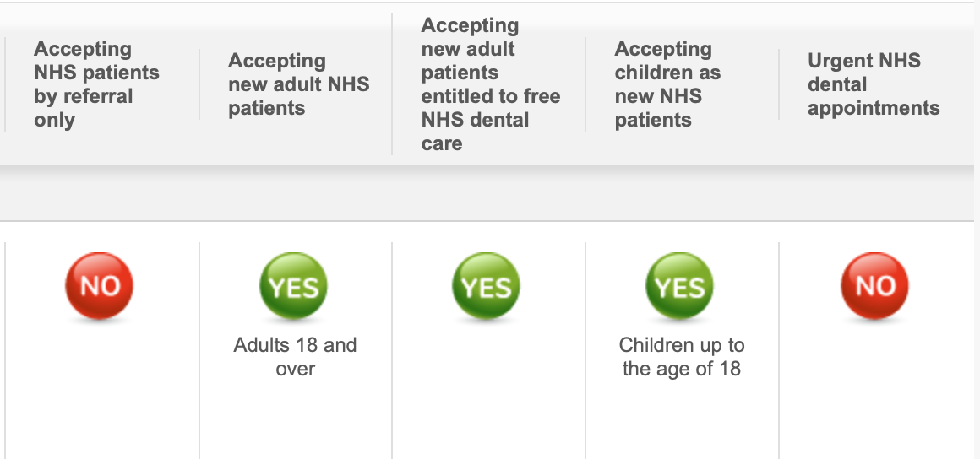  Edit Waiting times in the box  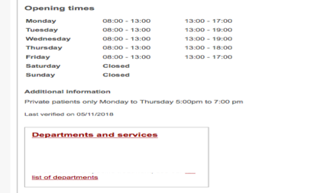
Dental Check by One
Work on developing access for 0-2 through DCby1 Programme
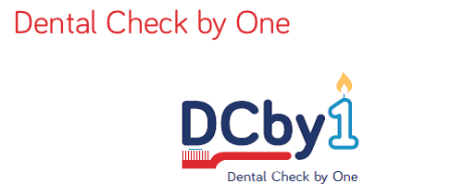
Prevention | Universal Evidence Based Prevention  Complete the DBOH Audit and develop an appropriate action plan. Communicate the results and action plan at the Practice meetings and Network meetings.  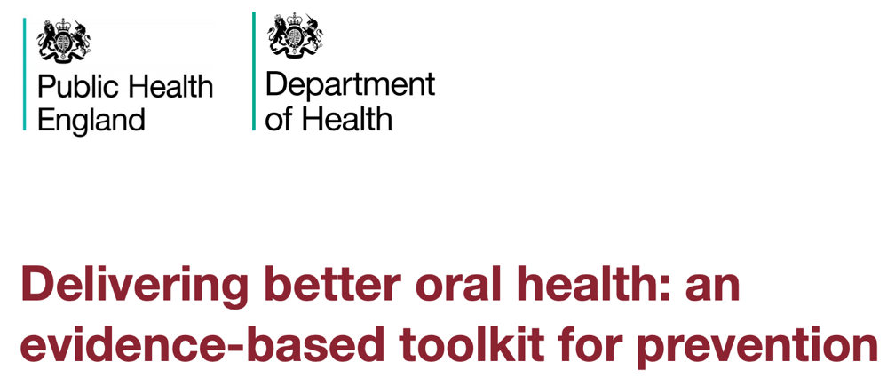
Delivery of Targeted Prevention pathways by trained DCPs or other qualified members of the team.
- Ensure patients are referred into the prevention clinics where they receive the two or more appointment pathways.
Programme Meetings | Practice meetings and Network meetings are held every six months with perhaps network meetings held in the interval between practice meetings.  Champions coordinate the practice meetings and organise the cluster network meetings. The Network meetings need to include between 2 and 8 sites within a local area. See resources for guidance on Programme meetings.
Working with the Community Dental Services | The CDS Service in your area will contact the Practice about arrangements for the “safe” discharge / referral of level 1 patients from the CDS to Primary dental Care. The champion ensures that systems are in place to facilitate the referral of patients from the CDS into the practice.
Working with the Local Authority | Signposting  The Local Authority Health Visitor and Social Care Teams will be in touch regarding the signposting of mainly 0-2s into the Practice to facilitate the DCby1 Programme for access and prevention. The champion will be the main contact to ensure that systems are in place to enable effective signposting.  Was Not Brought Policy  The champion will work with the practice to ensure that the was not brought policy is effectively administered – see resources.
MECC Link Referral | 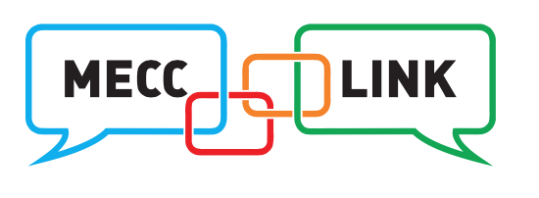  The champion will support the MECC referral pathways for patients wishing to be referred to health and wellbeing services for smoking cessation, alcohol awareness and weight management. Patients that wish you to ACT and refer for support- use the MECC link to action:  http://www.mecclink.co.uk
Data Collection | Data collection enables NHSE to establish Programme outcomes and Practices to demonstrate compliance and Programme activity. See resources.  The champion needs to ensure that data is collected effectively.
Data Submission | Data is submitted quarterly in March, June, September and December using the data submission link – see resources

